**COMP1011 – Advanced Web Programming**

**Assignment 1**

**Personal Portfolio Site**

Due class #4 (February 1st, 2013) @ midnight

Value 15%

Personal Portfolio Site **Maximum Mark:** **69**

**Overview**: Using your accumulated knowledge of HTML5, CSS3 and JavaScript, create a Personal Portfolio Web site that includes a unique **site logo**, **personal bio**, **portfolio section** (which will be used to house links to all of your **Assignments** and **projects** for the semester), a **Services** section, links to your **GitHub** site and a **Contact** page. Also, include a **“Call to Action” button**, a **“Featured Work” slider** and a **“**K**eep Connected”** panel.

Please use the following wireframe as a **guideline only** (in this case I don’t want to stifle your creativity):

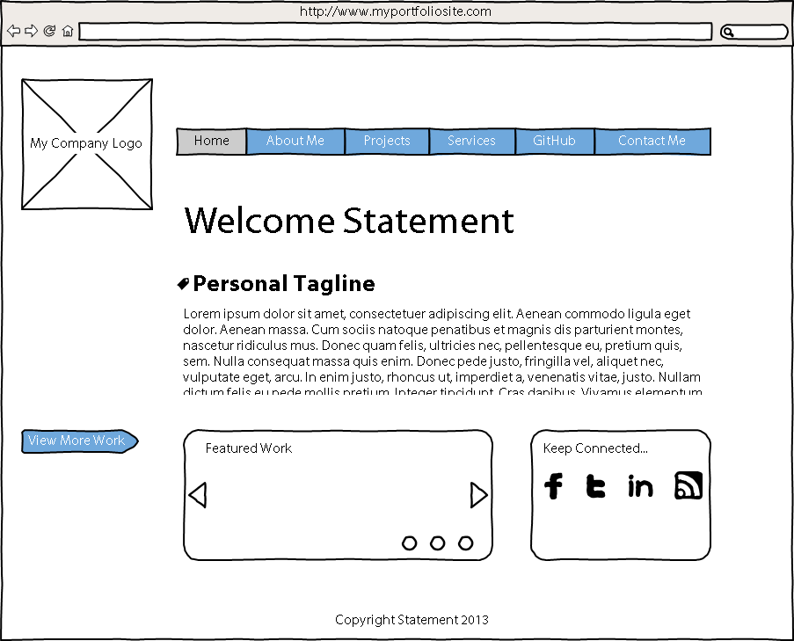

**Instructions :**

This site must include at least 5 pages – your **Home page**, an **About Me** page, a **Projects page**, a **Services page**, and a **Contact Me** page.

**(12 Marks: GUI, 20 Marks: Content, 12 Marks: Functionality, 5 Marks: Internal Documentation, 10 Marks: External Documentation, 4 Marks: Version Control)**

1. Your **Home page** should include the following components **(6 Marks: GUI, 6 Marks: Content, 6 Marks: Functionality):**
   1. A unique company logo (1 Mark: GUI, 1 Mark: Content).
   2. A **Nav Bar** that includes links to the primary pages of your site including: **Home**, **About** **Me**, **Projects**, **Services**, **GitHub** (you must sign up for this), and **Contact Me** (2 Marks: GUI, 2 Marks Functionality).
   3. A welcome statement (1 Mark: Content).
   4. A **Personal Tagline** and **your mission statement**. Your tagline should be short and snappy, summarizing what you do. Your mission statement includes at least 3 reasons for doing what you do. (2 Marks: Content).
   5. A **Call to Action Button**. This is the “Next Step” that users of your site will take to see more of your work. (1 Marks: GUI, 1 Mark: Functionality).
   6. A “**Featured work” slider**. This should display a series of images (a minimum of 3) that are each a **snapshot** of your latest projects. Each image should take you to the related project when clicked (1 Mark: GUI, 1 Mark: Content, 2 Marks: Functionality).
   7. A “**Keep Connected” Panel**. Make it clear that users can follow you on **twitter**, **Facebook**, **LinkedIn**, **YouTube** or other social networking sites that you are *actively using* and relevant to your work (1 Mark: GUI, 1 Mark: Functionality)
   8. A **footer** that includes your **copyright Statement** (1 Mark: Content).
2. Your **About Me page** should include the following components **(1 Marks: GUI, 5 Marks: Content, 1 Marks: Functionality):**
   1. Your site’s **Nav Bar** that clearly shows the page that is “Active” (1 Mark: GUI, 1 Mark: Functionality).
   2. A current image of you. No Avatars! (1 Mark: Content).
   3. A **bio section** that includes **your latest CV** and a bit about you (2 Marks: Content).
   4. A **footer** that includes your **copyright Statement** (1 Mark: Content).
3. Your **Projects page** should include the following components **(2 Marks: GUI, 4 Marks: Content, 2 Marks: Functionality):**
   1. Your site’s **Nav Bar** that clearly shows the page that is “Active” (1 Mark: GUI, 1 Mark: Functionality).
   2. At least **3 Images** representing your **current projects** and / or **assignments**. When the user **clicks** on these images they can either link to their location on **GitHub,** a separate sub-page of your site that includes details of the project or **previous work** that you have done for other courses and / or clients (1 Mark: GUI, 3 Marks: Content, 1 Mark: Functionality).
   3. A **footer** that includes your **copyright Statement** (1 Mark: Content).
4. Your **Services page** should include the following components **(1 Marks: GUI, 3 Marks: Content, 1 Marks: Functionality):**
   1. Your site’s **Nav Bar** that clearly shows the page that is “Active” (1 Mark: GUI, 1 Mark: Functionality).
   2. A Services Section that includes related images and text of the services you offer. Your tagline summed up what you do, but you’ll want to go into a bit more detail here about each service that you offer. Make it **clear**, and break it down: **Web design**, **development**, **video**, **copywriting**, **branding**, etc. (2 Marks: Content).
   3. A **footer** that includes your **copyright Statement** (1 Mark: Content).
5. Your “**Contact Me” page** should include the following components **(2 Marks: GUI, 2 Mark: Content, 2 Marks: Functionality):**
   1. Your site’s **Nav Bar** that clearly shows the page that is “Active” (1 Mark: GUI, 1 Mark: Functionality).
   2. A “**Keep Connected” Section**. This section should be similar to the Panel on your home page. You can include additional information or subscription feeds here if it makes sense to do so. (1 Mark: GUI, 1 Mark: Functionality)
   3. A **“Contact Info” Section.** Include your email address, work address and contact number(s). (1 Mark: Content).
   4. A **footer** that includes your **copyright Statement** (1 Mark: Content).
6. Your site includes well **Structured** HTML, CSS, JavaScript, etc. **(6 Marks: Site Structure):**
   1. Your site uses **Semantic Markup** (HTML5) that adheres to best practices and is separated from its presentation (1 Marks: Site Structure).
   2. Your **CSS** rules reside in separate file(s) in their own folder and adhere to best practices (1 Mark: Site Structure).
   3. Your **JavaScript** files (and other external code) are contained in their own folder and are appropriately linked to your site. (1 Mark: Site Structure).
   4. Your **images and multimedia assets** are contained in their own folder and appropriately linked to your site (1 Mark: Site Structure).
   5. All Your Code (HTML, CSS, JavaScript, etc.) is error free (2 Marks: Site Structure).
7. Include **Internal Documentation** for your site **(5 Marks: Internal Documentation):**
   1. Ensure you include a **comment** **header** for your **html**, **CSS and JavaScript files** that indicate: the **File name**, **Author's name**, **web site name**, **file description** (2 Marks: Internal Documentation).
   2. Ensure you include a **section headers** for all of your **html structure, CSS style sections,** and any **functions** (1 Marks: Internal Documentation)
   3. Ensure all your code uses **contextual variable names** that help make the files human-readable (1 Marks: Internal Documentation).
   4. Ensure you include **inline comments** that describe your GUI Design and Functionality. (1 Marks: Internal Documentation)
8. Create an **External Document** (simple style guide) for your Site that includes **(10 Marks: External Documentation)**:
   1. A **company Logo** (1 Marks: External Documentation).
   2. **Table of contents** (1 Marks: External Documentation).
   3. A **brief description** of your site (1 Mark: External Documentation).
   4. A **Nav Bar section** detailing how your Nav Bar looks (image capture) and how it functions (arrows and labels) (1 Mark: External Documentation).
   5. A **Colours section** that includes examples of your sites colours (swatches) and hexadecimal values of each colour in a table or grid. (2 Marks: External Documentation).
   6. A **Typography section** that includes a **screen capture** of the home page with arrows that indicate the **font**, **size** and **colour** used for the typography. Include a table or grid (2 Mark: External Documentation).
   7. A **Wireframes Section** that include a wireframe image and appropriate arrows and labels for each template of your site (1 Marks: External Documentation)
   8. A **Branding Section** that includes Screen Shots (samples) of each of your site’s templates and an example of the logo (including colour key). (1 Marks: External Documentation).
9. Share your files on **Github** to demonstrate Version Control Best Practices **(4 Marks: Version Control).**
   1. Your repository must include **your code** and be well structured (2 Marks: Version Control).
   2. Your repository must include **commits** that demonstrates the project being updated at different stages of development – each time a major change is implemented (2 Marks: Version Control).

**Optional Site Features (i.e. Potential Bonus Marks).**

1. Include a **working form** for your Contact Me page.
2. Include a **site map** for your site.
3. Include **bread crumbs** to your site’s navigation scheme.
4. Include a **terms of use** link.
5. Include a **privacy policy** link.
6. Include **Icons** in your Nav Bar.
7. Use well-structured **HTML**, **CSS** and **JavaScript** (and jQuery) to make your site Adaptive to various viewport sizes.

**SUBMITTING YOUR WORK**

Your submission should include:

1. An external document (MS Word or PDF).
2. A zip archive of your website’s Project files or a link to GitHub (preferable).

Please zip all files in to a single project archive.



This assignment is weighted **15%** of your total mark for this course.

All Assignments are due at the beginning of class.

Late submissions:

* 10% deducted for each day late.

External code (e.g. from the internet or other sources) can be used for student submissions within the following parameters:

1. The code source (i.e. where you got the code and who wrote it) must be cited in your internal documentation.
2. It encompasses a maximum of 10% of your code (any more will be considered cheating).
3. You must understand any code you use and include documentation (comments) around the code that explains its function.
4. You must get written approval from me via email.